Community’s Best

Mayor Grants You Gas Card

Collect $767
(plus personal vacation expenses)
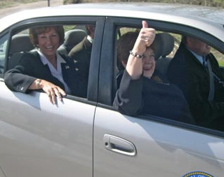

Inspired by SL County Mayor Nancy Workman & Guzzlegate 2004. Results may vary based on political connections. See www.accountabilityutah.org.

