WARNING!
DCFS Now Seizing Children of Meat-abstaining Families!

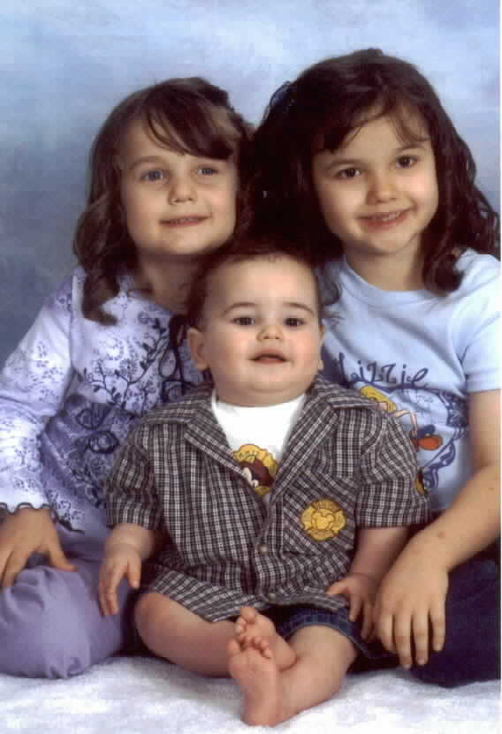
Look at the picture of Matthew Thaxton and his
two sisters. Do any of them look malnourished?
Thaxton Family Tragedy: This year, the entire Thaxton family suffered from carbon monoxide poisoning due to furnace exhaust asphyxiation. The youngest baby, Dan Thaxton, died of respiratory complications. Matthew, a second child from the same family, also became very ill.

DCFS Attacks Family: Despite ample evidence to the contrary, the Utah Division of Child and Family Services (DCFS) seized Matthew — citing the family’s vegetarian diet as the cause of his illness.

DCFS and Attorney General Mark Shurtleff are seeking to forever terminate this family’s right to be together.

State officials are turning a blind eye to this vicious attack on the Thaxton family.

The Thaxton family is only one of hundreds of innocent families being attacked by DCFS. This is a wake up call to all of us: DCFS is now bold and determined to find any ridiculous excuse to destroy families and increase their funding.

Our state legislators are entirely responsible for the actions of DCFS and for the laws that deprive innocent families of open courts and due process (such as jury trials). Call your state representative (538-1029) and senator (538-1035) and tell them to free the Thaxton family and start fighting for innocent families.

ACT NOW OR SOMEONE YOU LOVE MAY BE THE NEXT VICTIM!

For more information, see http://www.lifesave.org/FamilyVsState.htm

